“Reformed Vocational Training and Adult Education in the Service of Employment and the Family”
Ms. Ildikó Modláné Görgényi, Expert for Vocational Education and Adult Education
“Women, Families, Careers II. Cooperation between Generations” international conference
on 12 November 2015
at the Personal Hungary Exhibition for Human Resource Management
Millenaris “B” Building

- Introduction of obligatory kindergarten for children from age 3

Benefit: pre-school preparation

promotes equal opportunity

fewer unqualified early school leavers

supports family life

- Some statistic data (KSH 2015)

Children (thousand) in;

Kindergarten : 321, 5

Elementary school: 748,5

Secondary education: 471

Tertiary education: 271

- Enhanced teacher training

Professional support to preschool education

Evolving practical teacher training support system

Establishing Pedagogic(Teacher ?) Educational Centers (POK)

Creating institutes and collages

Developing Higher Education opportunities

- Developing major new educational programs and expanding criteria for public education including;

Objective strategic planning

Physical education

Computer programming

Arts faculties

Language programs

- Support for quality education

Digitalization of textbooks

Digital Portal for National Public Education for

students

parents

teachers

Developing school inspection criteria and capability

- Changes in vocational education I.

Extension of dual vocational education

Work experience learning modules

Practical training including formal student contract

Support of professional associations a fundamental requirement

- Changes in vocational education II.

„Vocational education for the benefit of the economy”- concept and change in the law
- Further extension of the dual vocational education to increase the number of student contracts and workplaces
- Increase student numbers in vocational education by making it a precondition for entrance to the labor market and eligibility for permanent employment

- Changes in vocational education III.
- vocational grammar school qualifications

Graduation + 2 professions= 5 years (4+1)
- vocational secondary school

Profession +graduation= 5 years (3+2)

- Changes in vocational education IV.
- Obtaining 2 professions is free
- Second profession can be obtained free in formal adult education through evening or postal tuition

Goal: employees should take part in ongoing education while working
- Increase the age limit for accessing vocational education from 21 years to 25 years

- Programs for underprivileged students
- Bridge I. Public Education programs
- Vocational Bridge Program: 2 years, for students with at least 6 years of elementary school, gives proof of basic education with part-qualifications

- Higher Education

Corporate recruitment

Possible introduction of dual systems

Learning through work experience

- Past, present and forecast of employment in Hungary

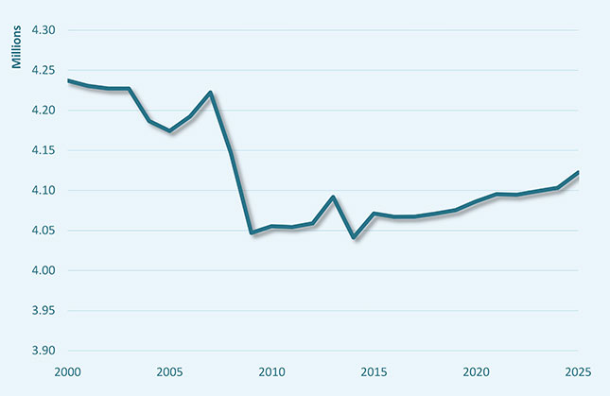

EUROSTAT

113. Unemployment rate went down by 0,1 % to 6,4 % in July-September 2015

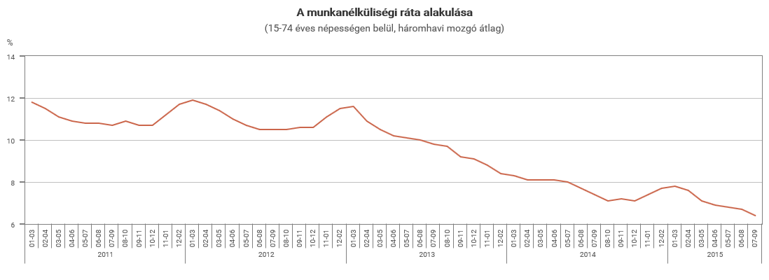

KSH

14

Employment rate, age group 15–64, 2014 (%)

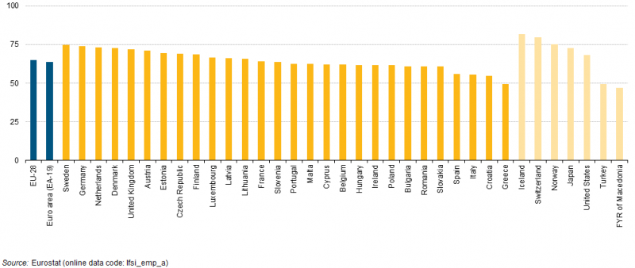

15.Employment rates by sex, age group 15–64, 2014 (¹) (%)

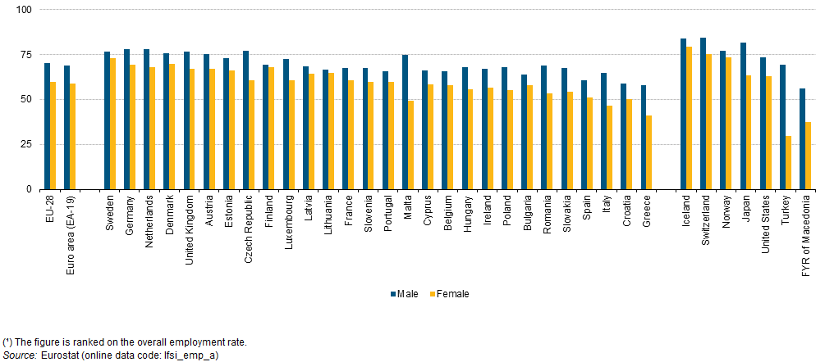

16.

Persons employed part-time, age group 15–64, 2014 (% of total employment)

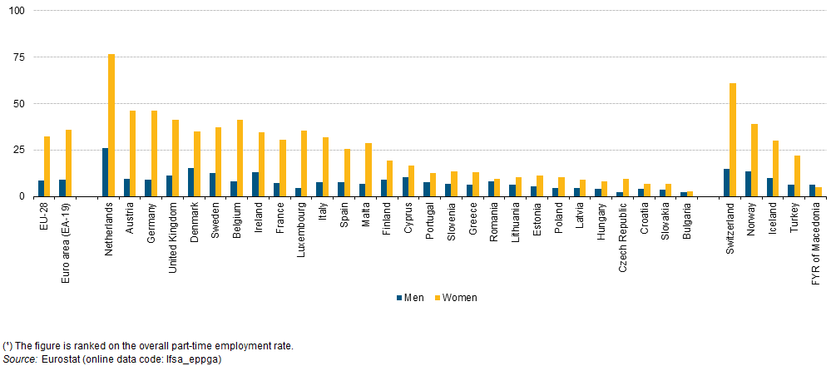

17. Talks about the development and future of vocational education (June 2015)

According to the Riga Declaration, there are 5 areas to prioritize up to 2020
- Developing and supporting practical vocational education at industry level
Improving the vocational education system to suit adults and qualifying youths
- Developing more flexible vocational education systems which are easier to access and complemented by personal counselling and evaluation systems
- Strengthening the development of competencies and skills needed in everyday working life
- Efficient training for teachers, masters and mentors in the vocational education system

Contact:

Ms. Ildikó Modláné Görgényi
Expert for Vocational Education and Adult Education,
Ex-Deputy Director General, Hungarian Labor Inspectorate
Association for Women's Career Development in Hungary
Organization in Special Consultative Status
with the UN Economic and Social Council
1118 Budapest, Ugron Gábor u. 28.
Hungary
Phone: +36 1 319 5245
Fax: +36 1 319 2017
E-mail: awcdh@t-online.hu
http:// www.womenscareer.org

